Журавлев К. В. ПИ20-1 ДЗ 15.09

**ICT SYSTEMS**

**What is an ICT system?**

ICT system is a concept that consists of many different individual computer systems connected using communication technology.

An ICT system is an set-up or organization of:

|  |  |  |  |
| --- | --- | --- | --- |
| **Hardware** | **Software** | **Data** | **Users** |
| The physical components that go into creating systems (computer hardware, smartphone hardware) | Programs or instructions that go basically code that are used to operate in computer systems | These are the stuff that flow through these systems and govern their operations as well | These are a individuals who will be affected or rely on computer systems in their everyday lives |

ICT systems are not computer systems

ICT system is rather a group of computers their software so the hardware and software as well as the communication networks that allow for data to transfer between these different systems as well as the users that are impacted or rely on these technologies every day.

Components of ICT systems:

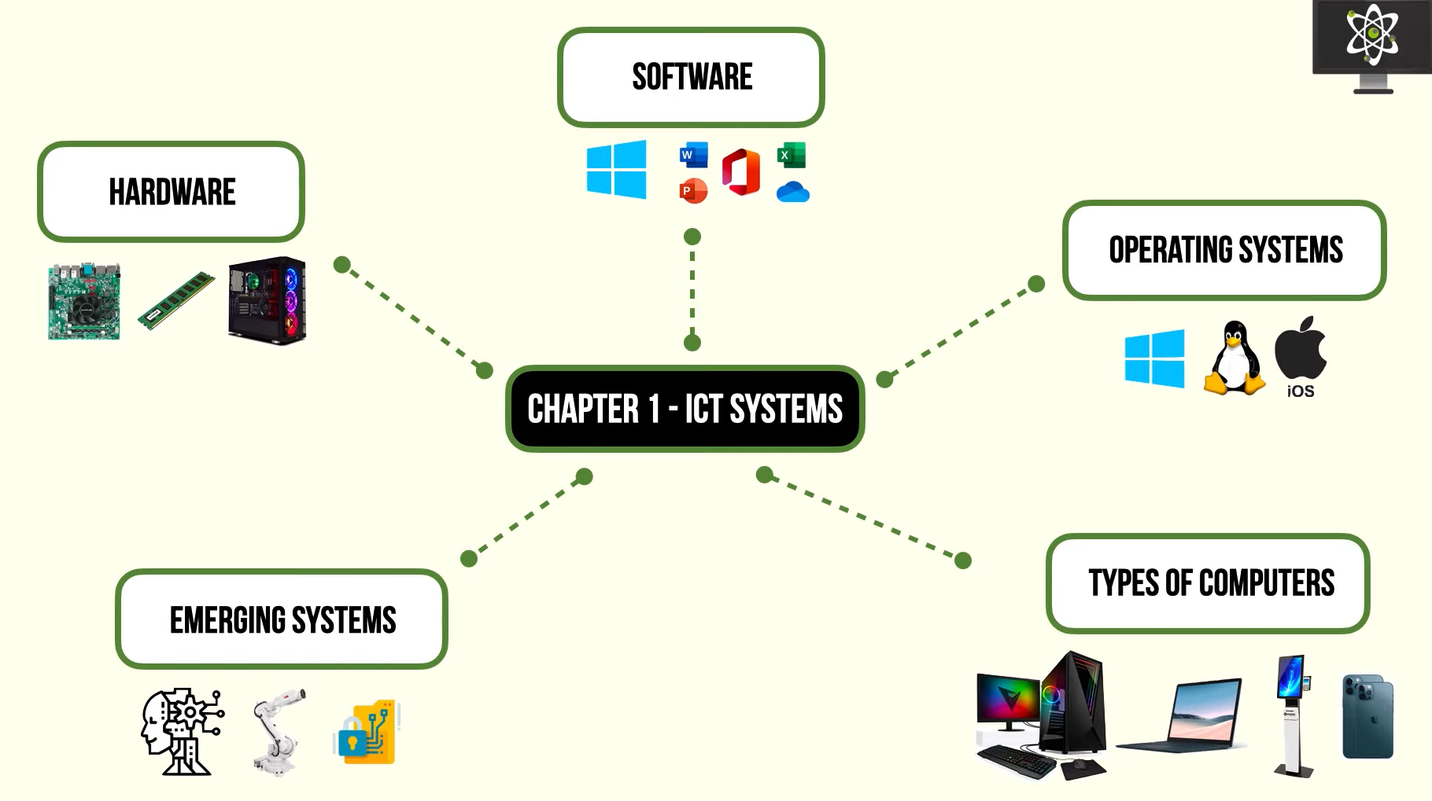

1. Hardware (motherboard, RAM)
2. Software (Microsoft office)
3. Operating systems (windows, linux, iOS)
4. Types of computers (PC, laptop, smartphone, kiosk)
5. Emerging systems (robotics, quantum cryptography, encryption)